**1.** Why are functions advantageous to have in your programs?

**Ans**: The advantage of function is to reduce the need for duplicate code and code Reusability.

We don’t need to write code over and over if using functions.

**2**. When does the code in a function run: when it's specified or when it's called?

**Ans:** A function runs when it’s called not when it’s specified.

**3.** What statement creates a function?

**Ans:** The def statement creates a functions like:

def functionName (Parameters):

function body

return value.

**4.** What is the difference between a function and a function call?

**Ans:** The difference between a function and a function call is A function is created to execute a particular task. We make a structure and when We call function then function executes. Without function call function cannot execute.

**5**. How many global scopes are there in a Python program? How many local scopes?

**Ans:** There is one global scope, and a local scope is created whenever a function is called.

**6.** What happens to variables in a local scope when the function call returns?

**Ans:** When a function returns, the local scope is destroyed, and all the variables in it are forgotten.

**7**. What is the concept of a return value? Is it possible to have a return value in an expression?

**Ans**: A return value is the value that a function call evaluates. Like any value, a return value can be used as part of an expression.

**8**. If a function does not have a return statement, what is the return value of a call to that function?

**Ans:** If there is no return statement for a function then it returns value is None.

**9**. How do you make a function variable refer to the global variable?

**Ans:** If We want to refer to a global variable in a function we can use the global keyword to declare global variables.

**10.** What is the data type of None?

**Ans:** The data type of None is NoneType.

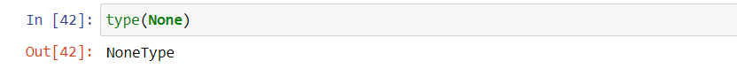

**11.** What does the sentence import areallyourpetsnamederic do?

**Ans:** That import statement imports a module named areallyourpetsnamederic.

**12.** If you had a bacon() feature in a spam module, what would you call it after importing spam?

**Ans:** bacon() function can be called with spam.bacon().

**13.** What can you do to save a programme from crashing if it encounters an error?

**Ans:** Write those codes inside try block from which can crash and use except block to handle those.

**14.** What is the purpose of the try clause? What is the purpose of the except clause?

**Ans**: The purpose of the try clause is to write the codes which can encounters errors and to handle those We use except clause.

